CPE301 – SPRING 2019

Design Assignment 4A

Student Name: Chris Barr

Student #: 2000682859

Student Email: barrc1@unlv.nevada.edu

Primary Github address: https://github.com/BarrChris

Directory: https://github.com/BarrChris/submission_da.git

Submit the following for all Labs:

1. In the document, for each task submit the modified or included code (only) with highlights and justifications of the modifications. Also, include the comments.
2. Use the previously create a Github repository with a random name (no CPE/301, Lastname, Firstname). Place all labs under the root folder ESD301/DA, sub-folder named LABXX, with one document and one video link file for each lab, place modified asm/c files named as LabXX-TYY.asm/c.
3. If multiple asm/c files or other libraries are used, create a folder LabXX-TYY and place these files inside the folder.
4. The folder should have a) Word document (see template), b) source code file(s) and other include files, c) text file with youtube video links (see template).

1. **COMPONENTS LIST AND CONNECTION BLOCK DIAGRAM w/ PINS**

List of Components used

* Atmega328P
* Multi-Function Shield
* TB6612FNG (H-Bridge)
* Breadboard
* UNLV ECE Lab Board
* 9 wires

Block diagram with pins used in the Atmega328P

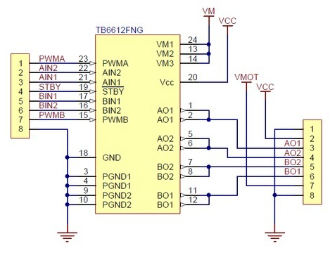

H-Bridge

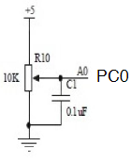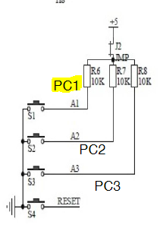

Onboard Potentiometer Pushbutton (PC1)

1. **INITIAL/MODIFIED/DEVELOPED CODE OF TASK 1/A**

/*

* DA4A.c

*

* Created: 4/12/2019 11:58:51 AM

* Author : Chris

*/

#define F_CPU 16000000UL

#include <avr/io.h>

#include <avr/interrupt.h>

#include <util/delay.h>

volatile unsigned int ADCVal**;** // Holds ADC Register value

char motor **=** 0**;** // Holds the state of the motor (ON/OFF)

void timer_init **(**void**);** // Function declaration for timer

void ADC_init **(**void**);** // Function declaration for ADC

int main**(**void**){**

timer_init**();** // Initializes timer

ADC_init**();** // Initializes ADC

**while** **(**1**)**

**{**

// main loop

PORTB **=** **(**1 **<<** PB5**);** // Keeps that annoying LED on shield turned off

**}**

**}**

ISR**(**PCINT1_vect**)**

**{**

**if(!(**PINC **&** **(**1 **<<** PINC1**)))** //BUTTON HAS BEEN PRESSED

**{**

_delay_ms**(**50**);** // Debounces button

**while(!(**PINC **&** **(**1 **<<** PINC1**)));** // Checks if button was pressed

**if(**motor**)** //START MOTOR

**{**

PORTB **|=** **(**1 **<<** PORTB1**);** // Turns on motor

ADCSRA **|=** **(**1 **<<** ADSC**);** // Starts conversion

**while((**ADCSRA**&(**1**<<**ADIF**))==**0**);** // Waits for conversion

ADCVal **=** ADC **&** 0x03FF**;** // Takes right 10-bits of ADC register

OCR1A **=** 10**\***ADCVal**;** // OCR1A value for duty cycle

**}**

**else** **if(!**motor**)** //STOP MOTOR

**{**

OCR1A **=** 0**;** // Reset register

PORTB **&=** **~(**1 **<<** PORTB1**);** // Turns off motor

**}**

motor **^=** 1**;** // Remembers state of button

**}**

**}**

void timer_init**(**void**)**

**{**

//Port directions

DDRB **=** **(**1**<<**1**);** // PB.1-2 (OC1A & OC1B) as output to generate PWM

DDRB **|=** **(**1**<<**5**);** // PB.1-2 (OC1A & OC1B) as output to generate PWM

DDRC **=** 0**;** // PORTC as input

PORTB **=** 0**;** // Initially turns off all PB5:0

//Timer1

TCCR1A **|=** **(**1 **<<** COM1A1**)** **|** **(**1 **<<** COM1B1**)** **|**

**(**1 **<<** WGM11**);** // enable PWM for OC1A & OC1B, Fast PWM, Non-inverted mode

TCCR1B **|=** **(**1 **<<** WGM13**)** **|** **(**1 **<<** WGM12**)** **|**

**(**1 **<<** CS11**);** // Prescaler = 8

ICR1 **=** 9999**;** // Timer1 TOP

//Interrupt Settings

PORTC **|=** **(**1 **<<** PORTC1**);**

PCICR **=** **(**1 **<<** PCIE1**);**

PCMSK1 **=** **(**1 **<<** PCINT9**);**

sei**();** // Enable global interrupts

**}**

void ADC_init **(**void**)**

**{**

// ADC initialization

DIDR0 **=** 0x1**;** // disable digital input on ADC0 pin

ADMUX **=** **(**1**<<**REFS0**);** // Reference = Aref, ADC0 (PC.0) used as analog input

// right-justified data

ADCSRA **|=** **(**1**<<**ADEN**)** **|** **(**1**<<**ADPS2**)** **|**

**(**1**<<**ADPS1**)** **|** **(**1**<<**ADPS0**);** // enable ADC, system clock used for ADC

ADCSRB **=** 0x0**;** // free running mode

**}**

1. **DEVELOPED MODIFIED CODE OF TASK 2/A from TASK 1/A**

N/A

1. **SCHEMATICS**

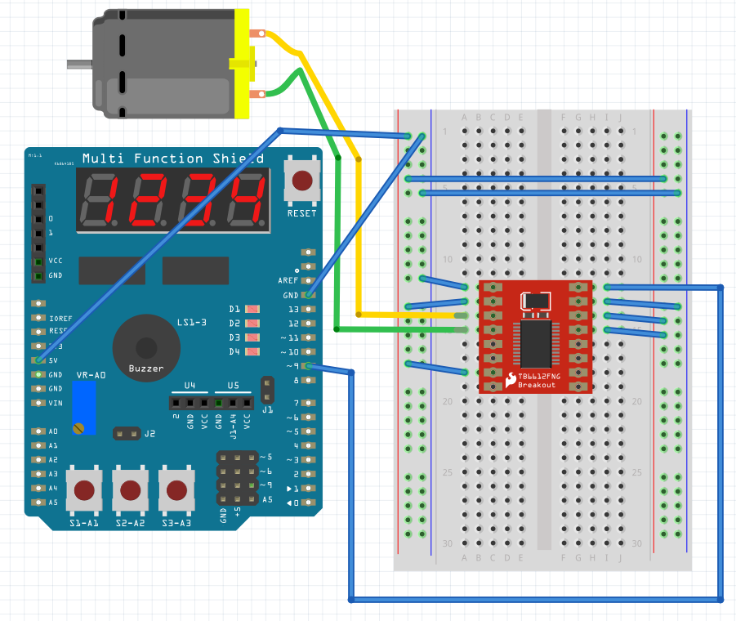

1. **SCREENSHOTS OF EACH TASK OUTPUT (ATMEL STUDIO OUTPUT)**

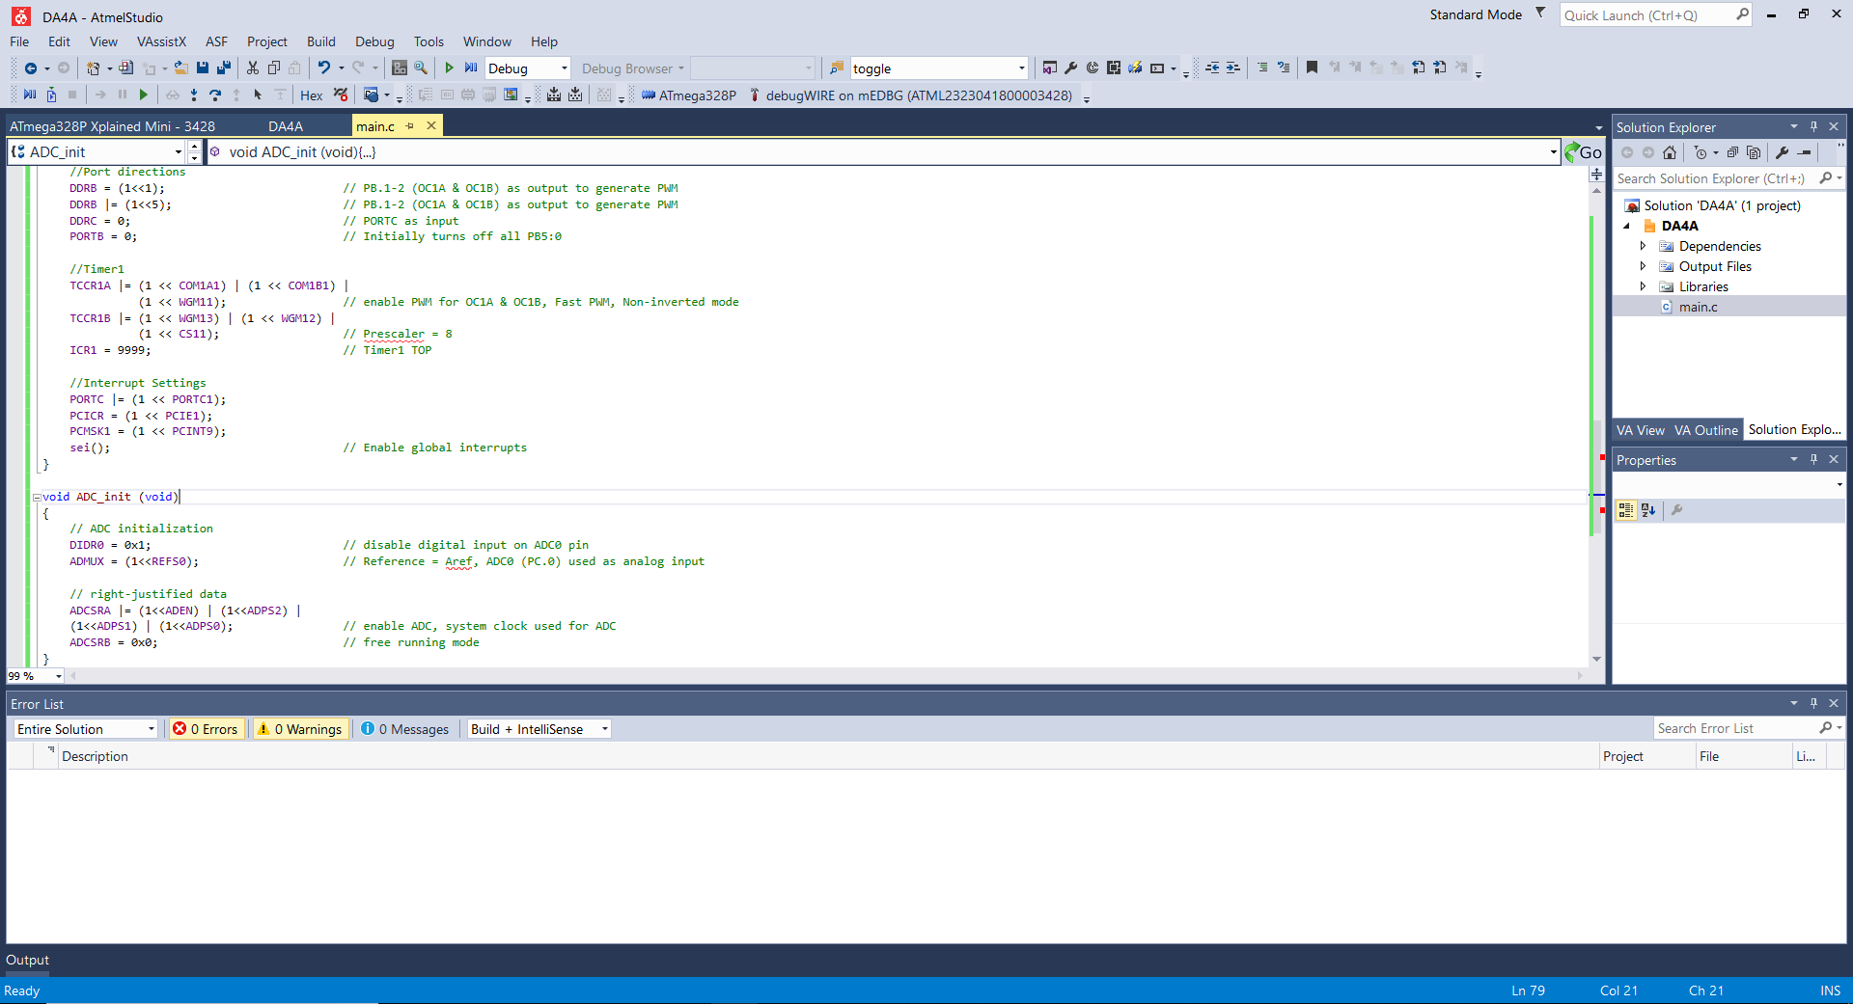

Shows the program running on Atmel Studio 7

1. **SCREENSHOT OF EACH DEMO (BOARD SETUP)**

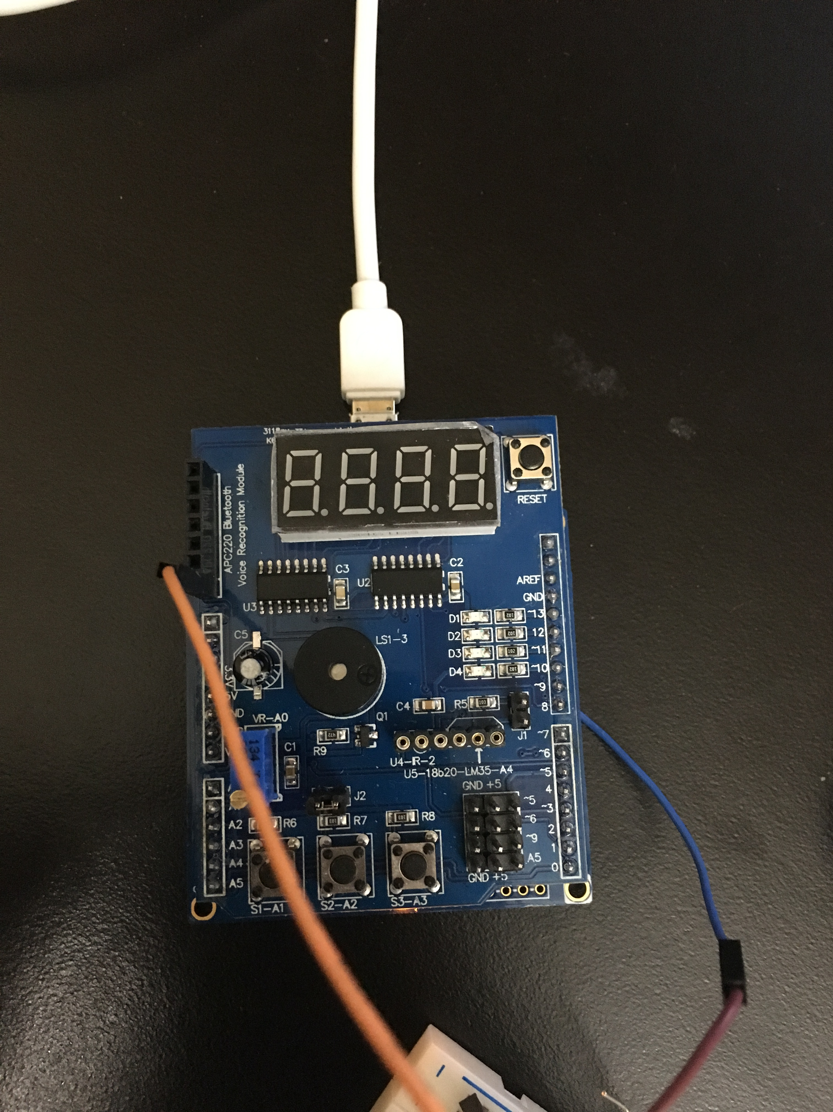

Picture of 328P wire connections

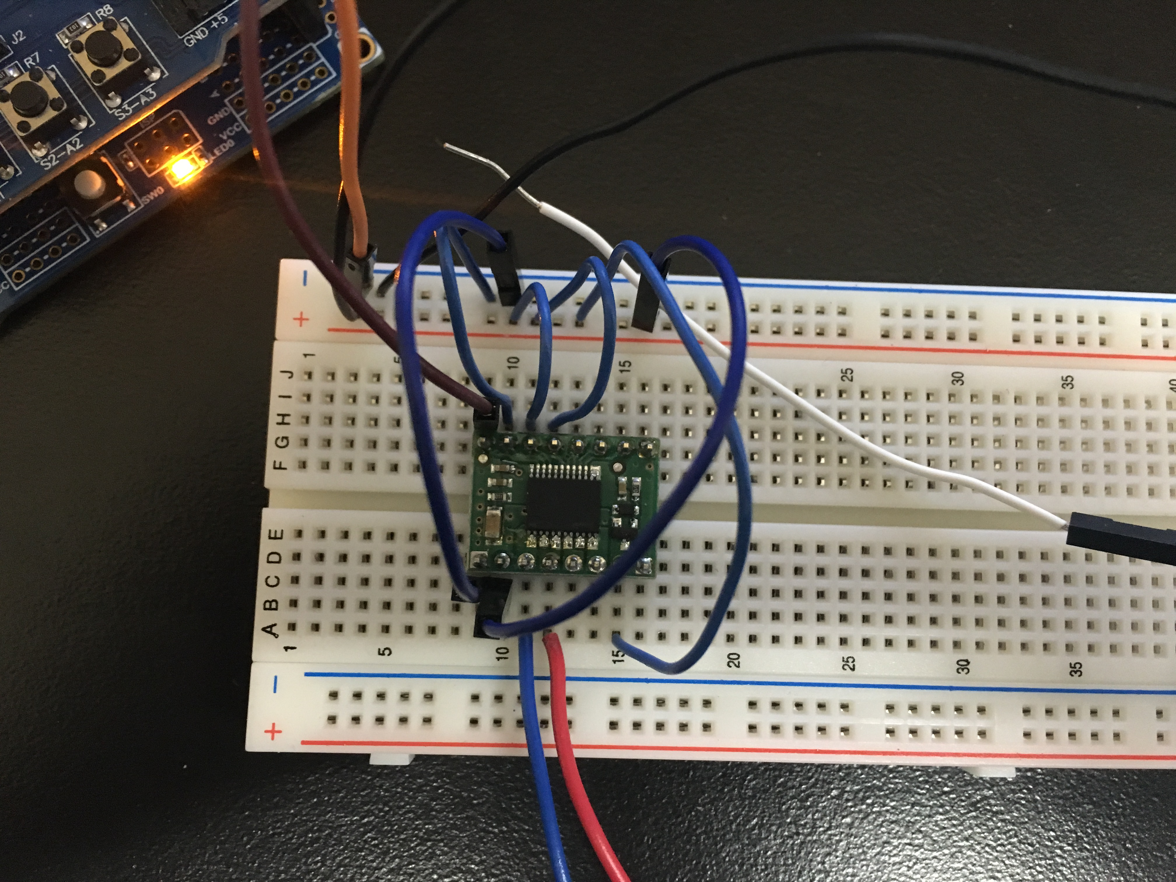

Breadboard connects the H Bridge to the 328P and the motor

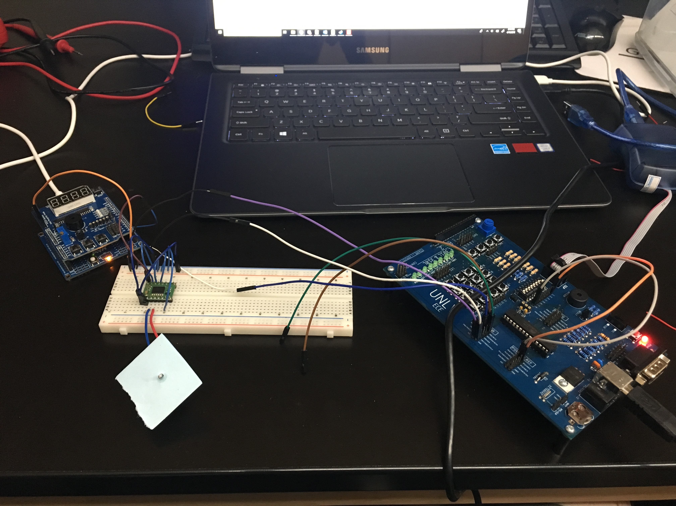

This is whole setup with the H Bridge connected to the 328p as well as the motor, and using the labs board for the external 5V power supply

1. **VIDEO LINKS OF EACH DEMO**

<https://www.youtube.com/watch?v=HDkbCUhdOjw>

1. **GITHUB LINK OF THIS DA**

<https://github.com/BarrChris/submission_da/tree/master/DesignAssignments/DA4A>

**Student Academic Misconduct Policy**

<http://studentconduct.unlv.edu/misconduct/policy.html>

“This assignment submission is my own, original work”.

Chris Barr